Visual Concepts
Quiz 1
Name:

- Match the following words with the definitions.

- Rhythm | - The content of an artwork.
- Content | - An element of design that communicates an idea or meaning beyond that of its literal form.
- Composition | - Is a symbol or a sign that has strong emotional power.
- Unity | - An idea conveyed through the artwork that implies the subject matter, story, or information the artist communicates to the viewer.
- Form | - A simple pictorial sign or group of signs intended to communicate without words.
- Subject | - A line or edge that continues from one form to another, allowing the eye to move smoothly through a composition.
- Design | - The degree of agreement existing among the elements in a design.
- Continuation | - A network of horizontal and vertical intersecting lines that divide spaces and create a framework of areas.
- Harmony | - An element of design based on the repetition of motifs.
- Icon | - It is the visual aspect of composition, structure, and the work as a whole.
- Grid | - The overall arrangement and organization of visual elements on the two-dimensional surface.
- Pictograms | - The pleasing combination of parts that make up a whole composition.
 | - Planned arrangement of visual elements to construct an organized visual pattern.

- Fill in the blank with the most appropriate word.
- ______________ :Stresses the importance of one element over the other.
- _________________: When a painting becomes transparent with age, earlier drafts or earlier images show through affecting the visual content of the final image.
- __________________________: grouping like objects together.
- ___________________: Is to create a sense of unity by combining elements that don’t appear, on the surface, to have much in common.
- ________________: A branch of philosophy concerned with the beautiful in art and how the viewer experiences it.

- Define the following words:
- Repetition
- Negative Space
- Critique

- Identify the concepts related in the following images.
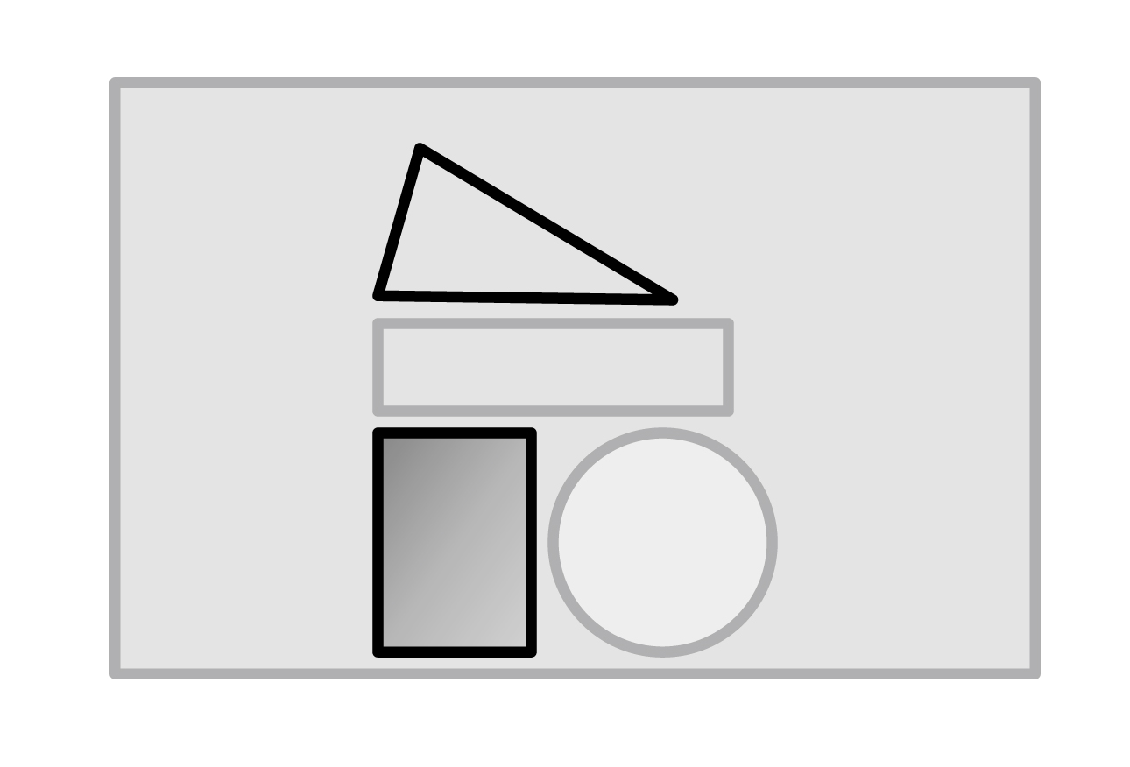 | 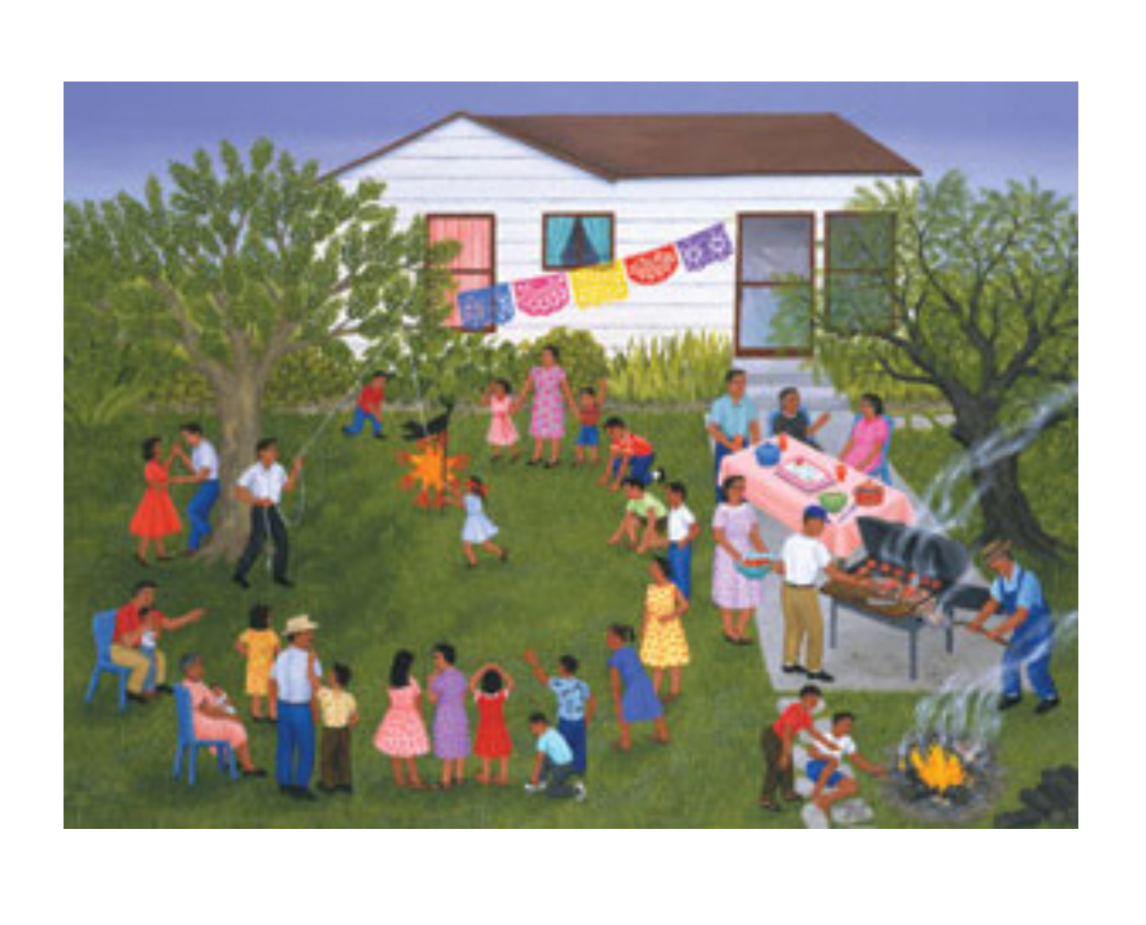

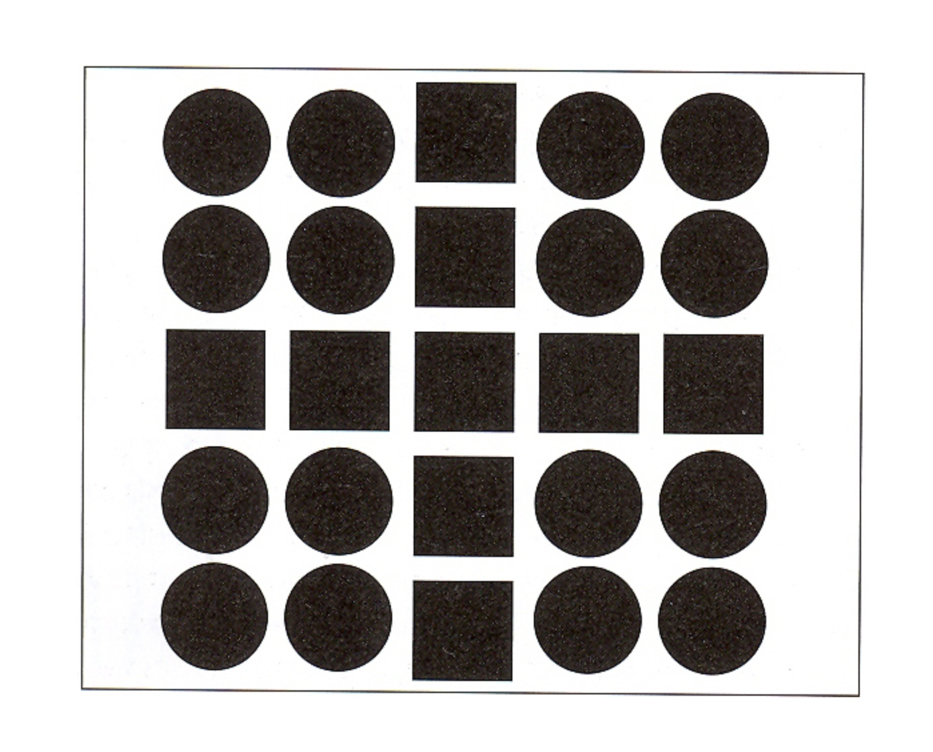 | 