Mid-Term Project
Deadline: Thursday, March 7 at the start of class.
Meet in our normal classroom.
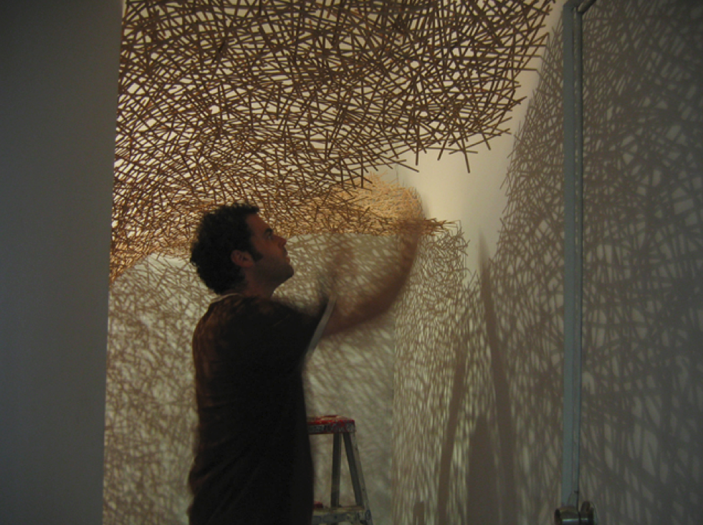
Project Details:
You will be assigned to a group of three or four for your mid-term. Each group will be required to do the following:
- Create a 3-d composition that expresses rhythm and repetition using found or recycled materials. (You can talk to Jorden Grimm, who oversees the recycling program, at recycle@nmhu.edu or 505-454-3491.
- The use of rhythm and repetition in your composition needs to support your group’s concept. This is key!
- In addition to your project, your group is required to submit a written artist’s statement (we will provide you with a sample artist’s statement). The statement must be typed and a minimum of 500 words. You can use statistics or information from the lecture to guide the creation of your project, but your project must have a conceptual framework and must be supported by facts.
Submission requirements:
- Your project must be 3 dimensional and there is no size restriction. Your group should expect to spend at least 8 hours on this project.
- A typed proposal is due from your group on Tuesday, February 26, you will have time after you complete your quiz to work with your group on a proposal. Please bring a HARD COPY to class for us to mark up with feedback, and email me the finalized version after class.
Your project, including set up, MUST be finished at the start of class on Thursday, March 7. We will meet in our usual classroom before branching out to your site-specific pieces.
Evaluation:
25% Achieving project goals (utilizing rhythm and repetition and incorporating a concept into the design)
25% Ability to present work + ARTIST’S STATEMENT (typed, and at least 500 words)
25% Care and craft of the presentation
25% Participation in critique

Groups:
Group 1 Group 2 Group 3 Group 4
Craig Leon Kristen Gerica
Cody Clarence Molly Brian
Gavin Demonte Kendra Jose

Proposal
Things to include and/or consider within your artist proposal:
- This project is to be thought of as less of “an assignment” but rather as a “piece”. We want you to be as creative as possible in the creation of this work. How can you use rhythm and repetition to convey an idea or concept? What are the best materials to use in order to translate these ideas?

- We recognize that some things may change once you’re in the throws of working on your piece; however, this proposal gives you the opportunity to order your ideas. Do they make sense? Are they interesting? Are you falling into the cliché? How does the idea relate to the form that it is going to take and the tools you are going to use to make the piece?

- Is your proposed project feasible to accomplish within the allotted time?

